Juno’s Kitchen

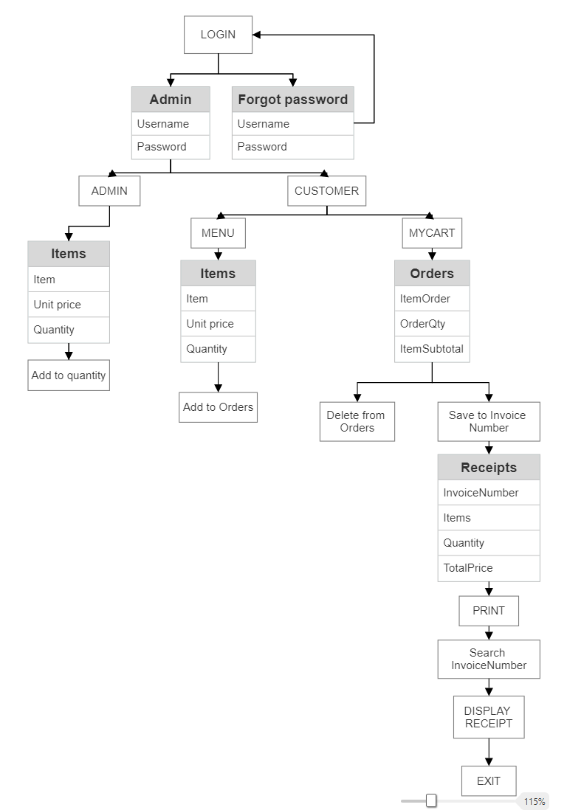

**LOGIN**

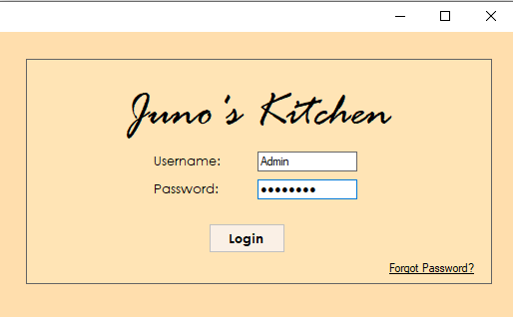

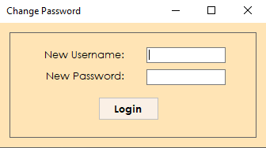

**Customer:**

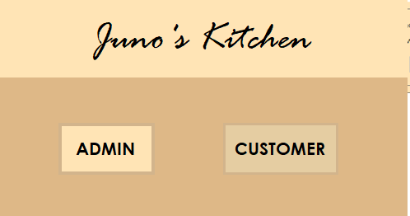

**MENU:**

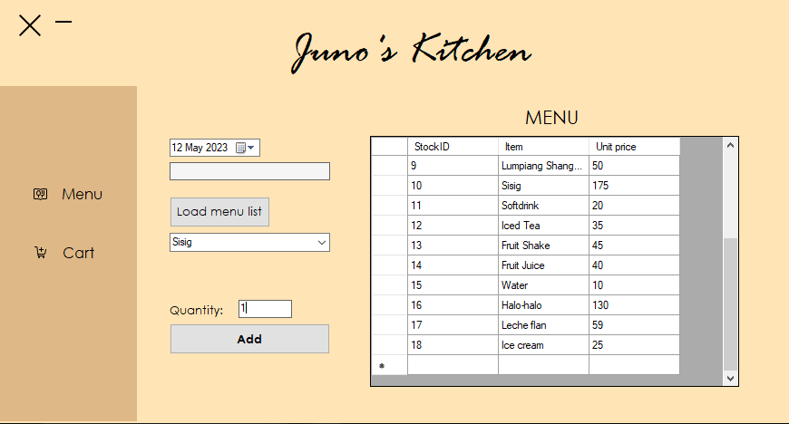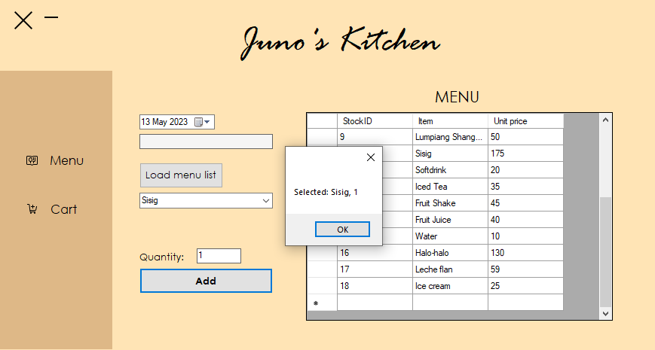

**CART:** 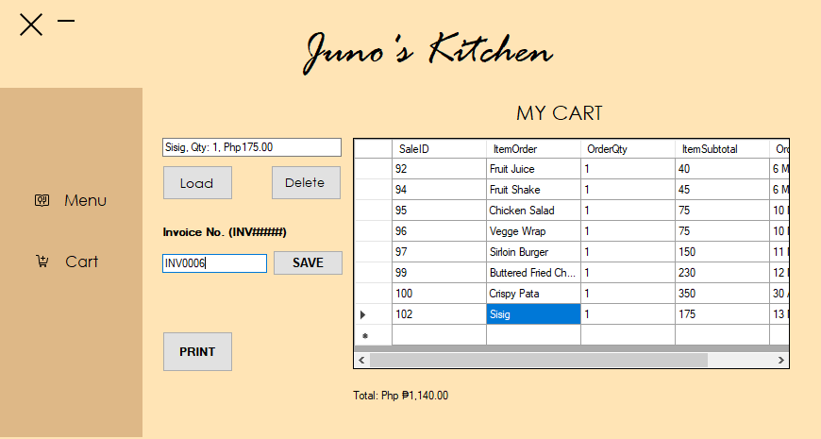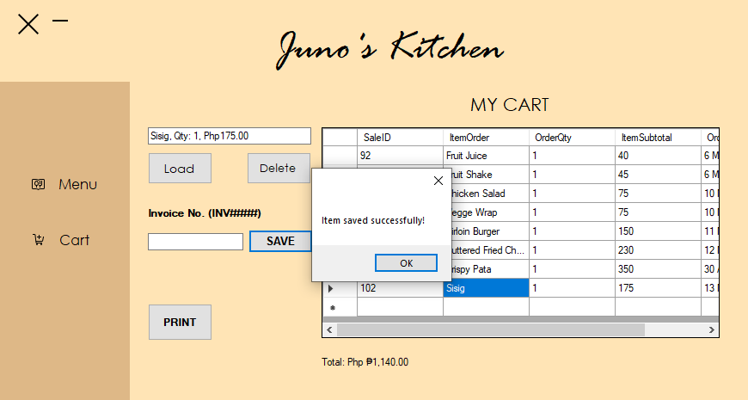

**PRINT RECEIPT:**

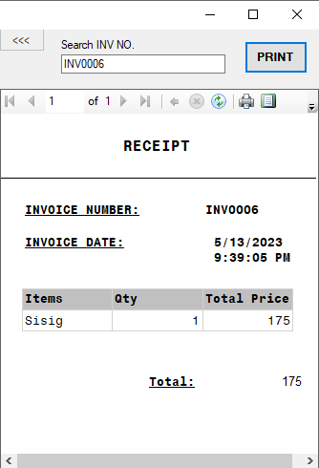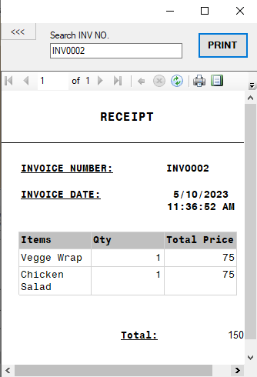

**ADMIN**

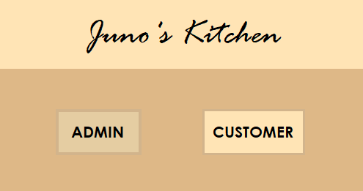

**INVENTORY:**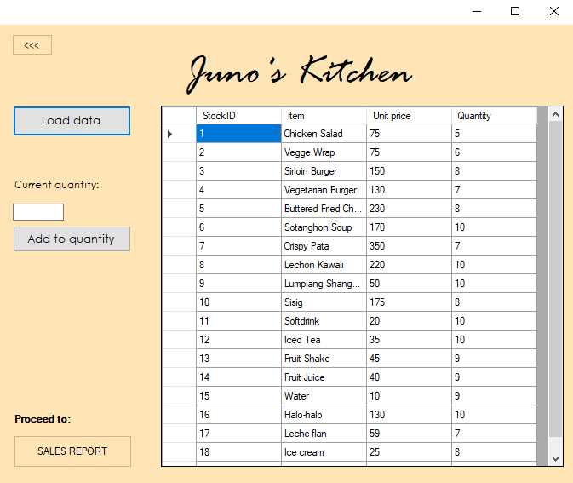

**ADD ITEMS STOCK QUANTITY:**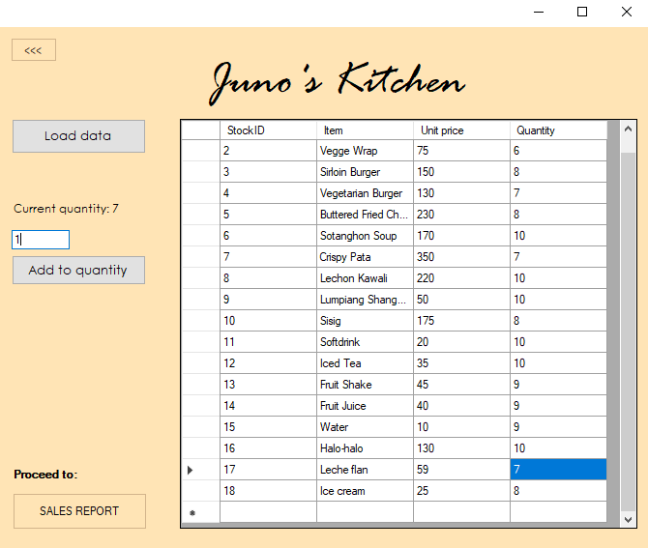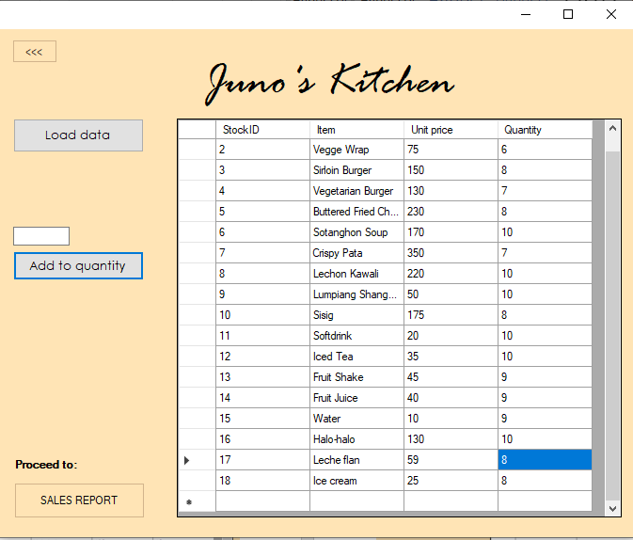

**SALES REPORT**

**SUMMARY**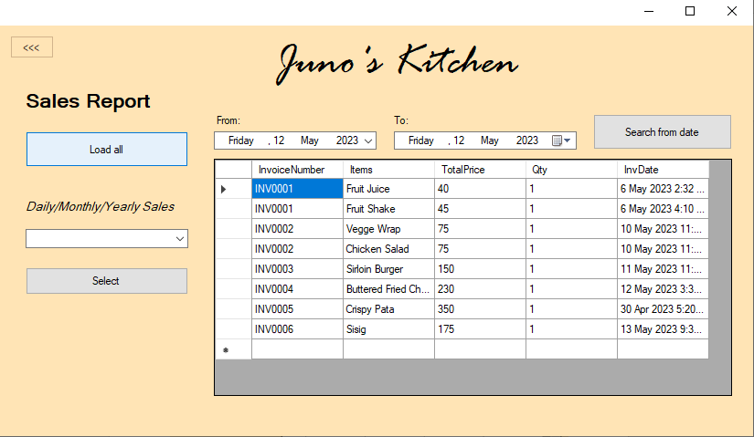

**SEARCH FROM SPECIFIC DATES**

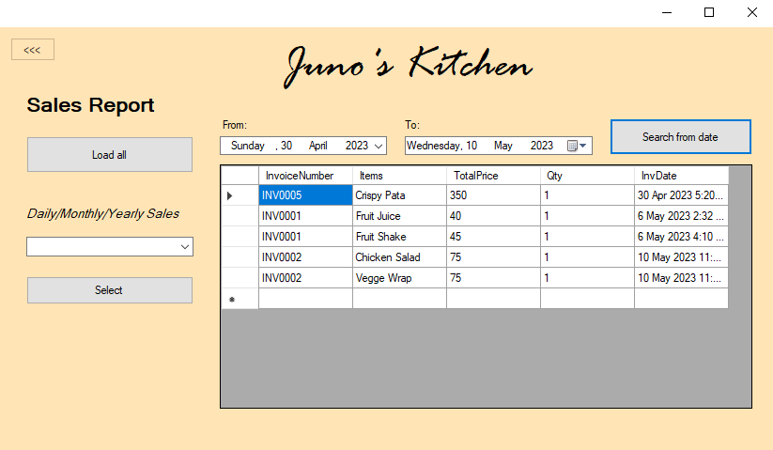

**DAILY/MONTHLY/YEARLY**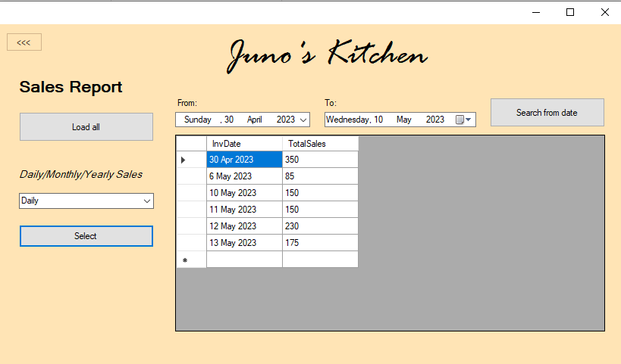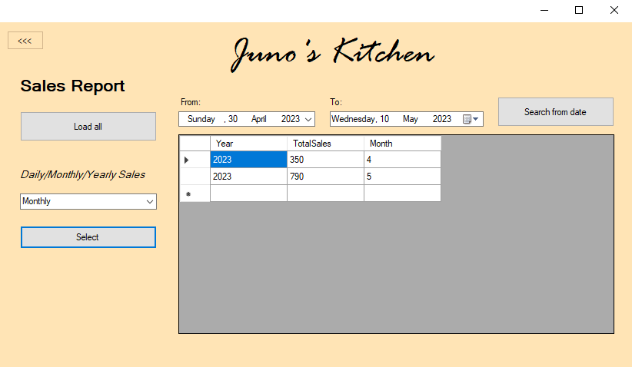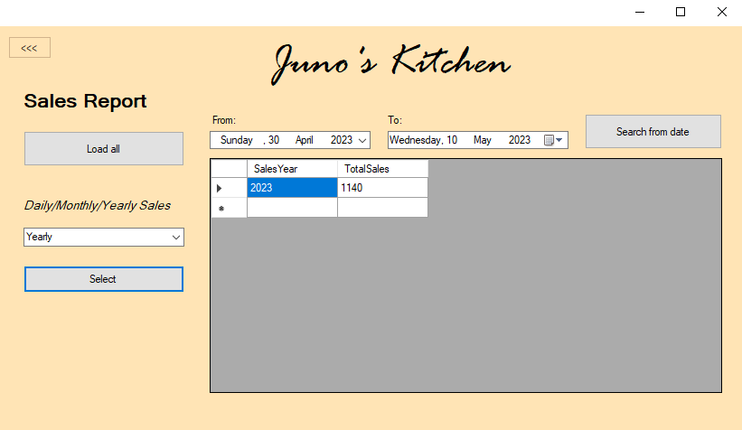

**SOURCE CODE:**

[AWID_OOP proj source code](https://cebuinstituteoftechnology-my.sharepoint.com/:f:/g/personal/venicebrooke_awid_cit_edu/EkWDB1qGH_FBjQqDkb8Qq1cBLbvJkAW8eD4SMXKRyf5bdQ?e=zEu0oi)